 | Lee Liebeskind  8500 16th Street  Silver Spring, MD 20910  Cell: (410)-852-8164  leeliebeskind@gmail.com | 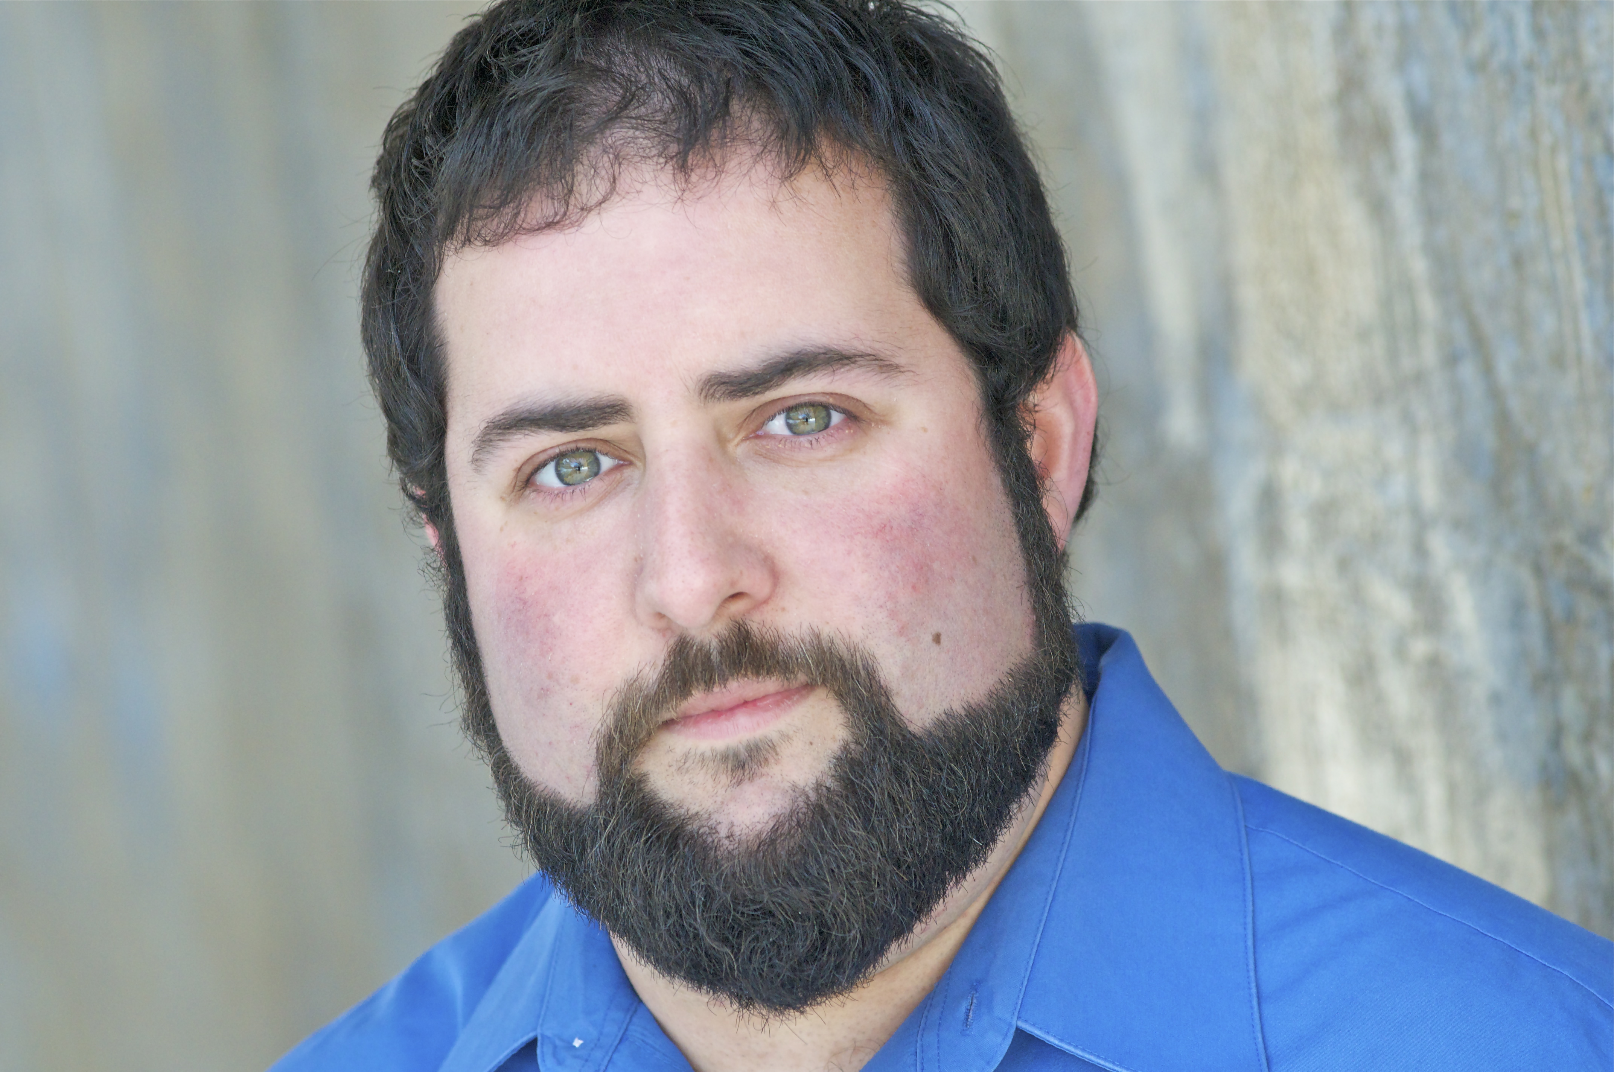

Height-5’7” | Eyes-Green
Weight-250lbs | Hair-Black
 | Voice- Baritone
Theatre Acting
Show | Role | Company | Director
Neverwhere | Tooley, Varney, Hammersmith, puppeteer | Rorschach Theatre | Jenny McConnell Fredrick
Astroboy and the God of Comics | Ensemble | Studio 2nd Stage | Natsu Oonda Powers
Mary Stuart | Lord Burleigh | Washington Shakespeare Company | Colin Hovde
Staring at The Sun | Turtle and George | Flying V | Jason Schlafstein
Klecksography (Home for the Holidays) | Dad | Rorschach Theatre Company | Grady Weatherford
Klecksography (Page 2 Stage Event) | Lee | Rorschach Theatre Company | Hunter Styles
Macbeth | Banquo | Push/Pull Theatre | Jessica Aimone
1001 | B: The One Eyed Arab, Sinbad, Mustafa, The Jinn, et al. | Rorschach Theatre Company | Randy Baker
The Marriage of Figaro | Antonio | Constellation Theatre Company | Allison Stockman
PUNCH—that’s the way we do it! | Cop, Executioner, The Devil | Dog and Pony DC | Wyckham Avery
Dream Sailors | Gil, et al. | Rorschach Theatre Company | Colin Hovde
Mad Breed | Sleepy | Active Cultures | Juanita Rockwell
F Word | Huge | The Inkwell | Patrick Torres
Antigone | Jonas | Forum Theatre | Michael Dove
Petri Dish Circus | The Ringmaster | Active Cultures | Jessi Burgess
Getting Out | The Guard | Journeymen Theater Ensemble | Deborah Kirby
Rough Magic | Caius Marcius/Alecto | Rorschach Theatre Company | Jenny McConnell Frederick
Much Ado About Nothing | Verges (Sign)  Don Pedro, Borrachio, Friar Frances (Voice) | Amaryllis Theatre Company/Gallaudet University | Mimi Kenny-Smith
Romeo and Juliet | Lord Capulet | National Players | Lenny Lebowitz
The Oedipus Cycle | Tiresias | National Players | Alan Wade
A Midsummer Nights Dream | Egeus/Snug | National Players | Clay Hopper
Our Town | Constable Warren/Professor Willard | National Players | Alan Wade
Staged Readings
Shakespeare Star Wars | Chewbacca | Flying V | Kevin Finklestein
Love, Faith and Other Dirty Words | Seth | Theatre J | Shirley Sorotsky
The Hour of Feeling/Urge for Going | George/ Hamzi | Theatre J | Lise Bruneau
El Coqui | Juracan | Artist Bloc | Andy Wassanatch
All In The Timing, “Variations on the Death of Trotsky” | Trotsky | Constellation Theatre Company | Gwen Grastorf
Eat Me | Roger | Rorschach Theatre Company | Grady Weatherford
Peer Gint | Bastard King et all | Forum Theatre | Patrick Torres
Her Love Was Vertigo | Narration and Assistant | Source Theatre Festival | David Dower
Ignus Fatus | Jo | The Hub Theatre | Jessi Burgess
Education
BS in Acting | Towson University
Viewpoints/Suzuki | Diane Smith-Sadak
Voice and Dialects | Stan Brown
Laban and Bartinian Fundamentals | Tom Casciero
Directing | Vincent Lancisi, John Manlove, Esieba Erobie
Performance Art Based Theatre | Dartington College of the Arts
Special Skills
Fire Spinning (Poi, Staff, Hoop), Stage Combat, Conversational American Sign Language, Dialects (Standard British, Cockney, New York, Southern, Irish, Russian), Film Editing (Premier and Final Cut) Marksmen (Rifle and Bow), Fencing, can walk/dance in 5 inch heels

Directing Resume or References available upon request

